GitHub Code Check-In Guide

File History:
S.No | Document Name | Version | Created By | Created Date | Modified By | Modified Date
1 | GitHub Code CheckIn Guide-v1.0.doc | v1.0 | Nagarjuna Goud Tummala | 03/06/2016

Step#: Open the Eclipse IDE
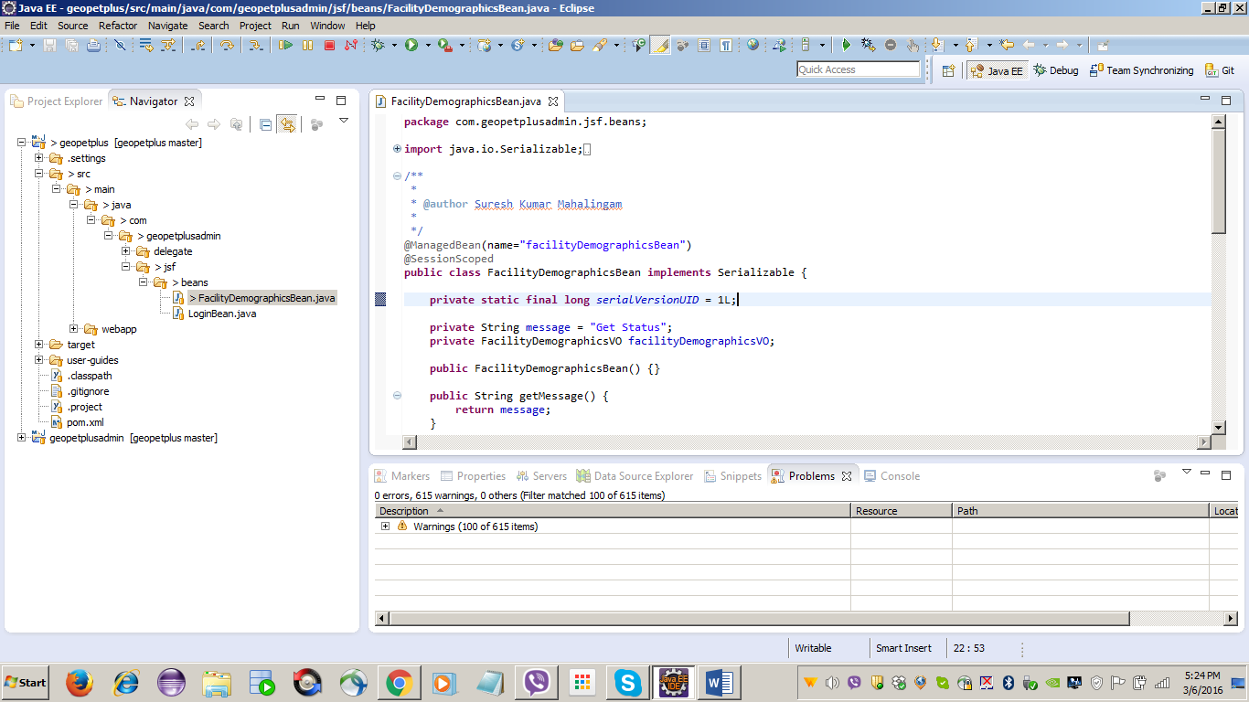

Step#: Open Synchronize Workspace to view “In Coming Code Changes” and “Out Going Code Changes” and “Any Conflicts”
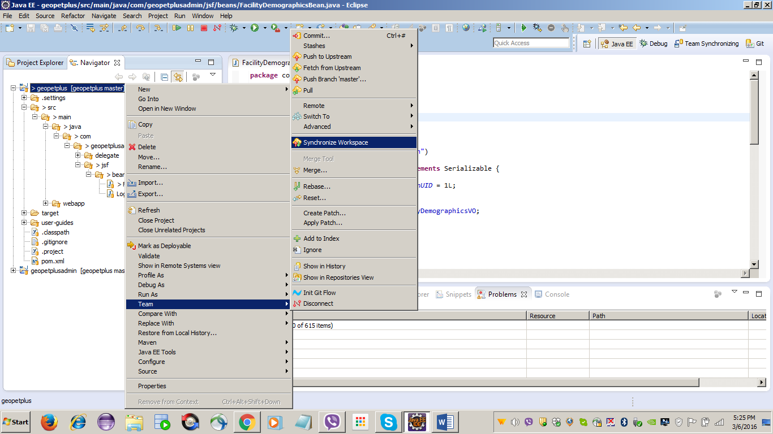

Step#: Click Yes
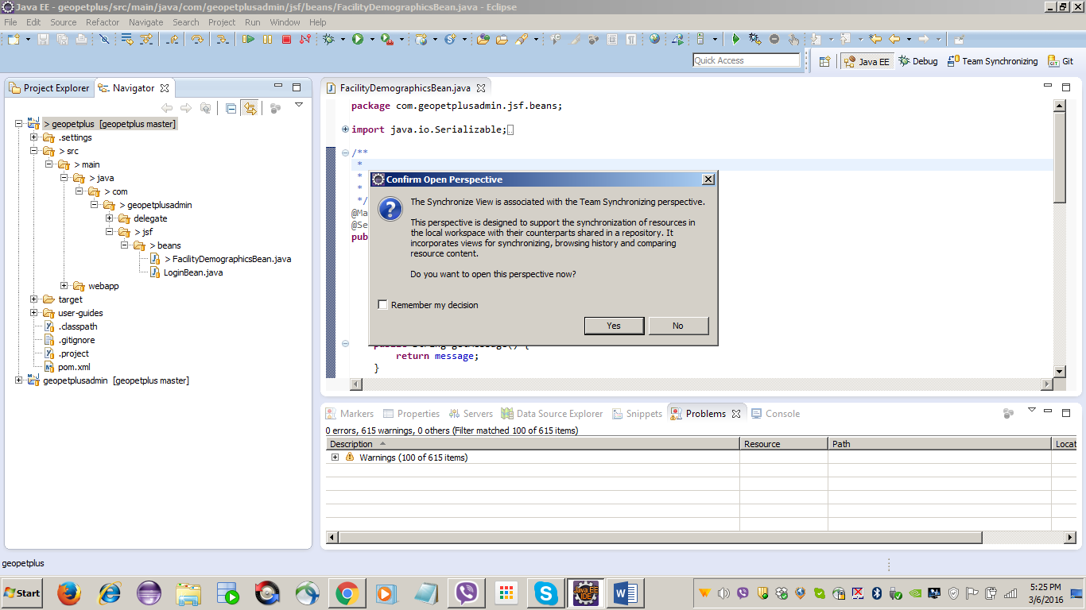

Step#: Here you can view “In Coming Code Changes” and “Out Going Code Changes” and “Any Conflicts”
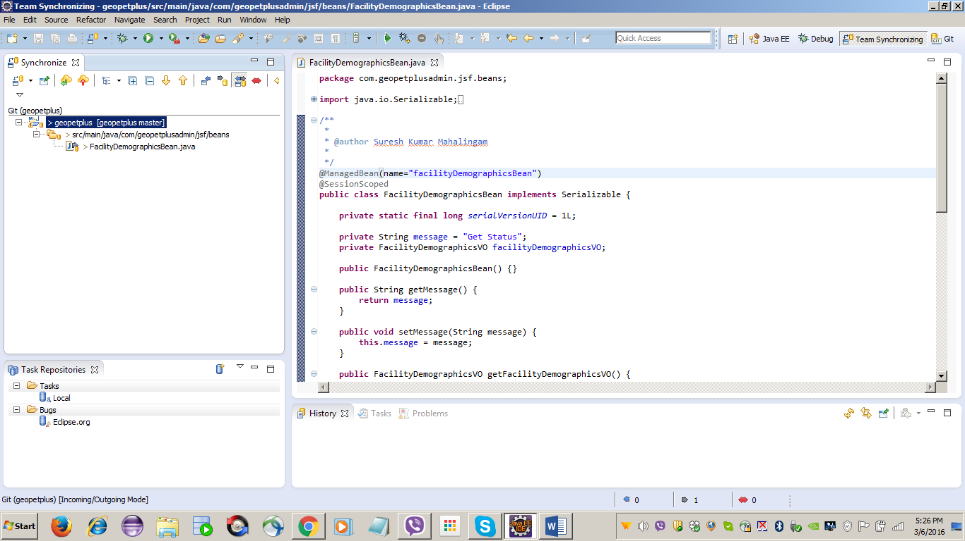

Step#: Select Add to Index
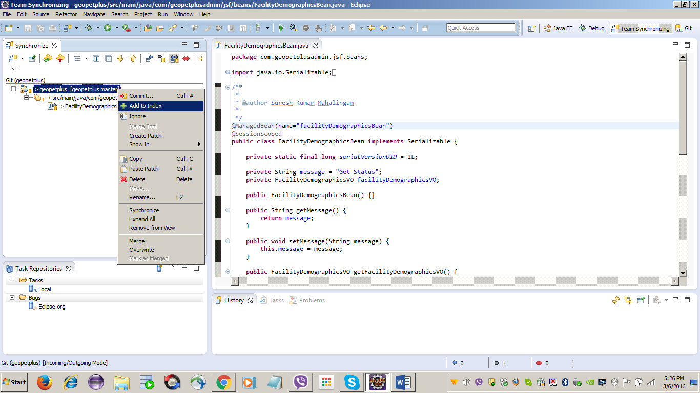

Step#: Select Commit…
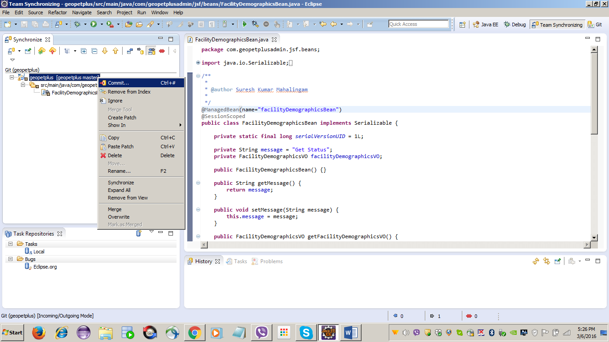

Step#: Add proper comment in Comment message section and select the files and click on the Commit and Push button
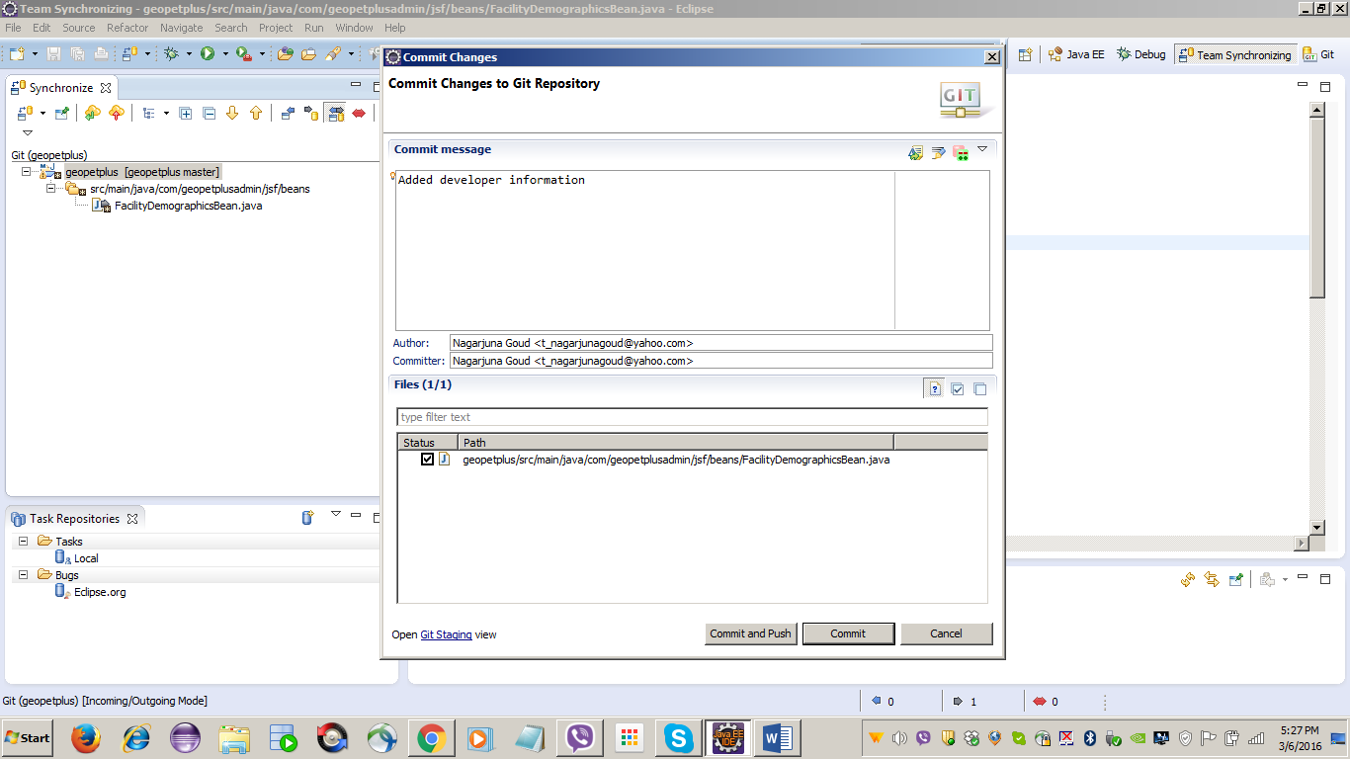

Step#: Click OK button
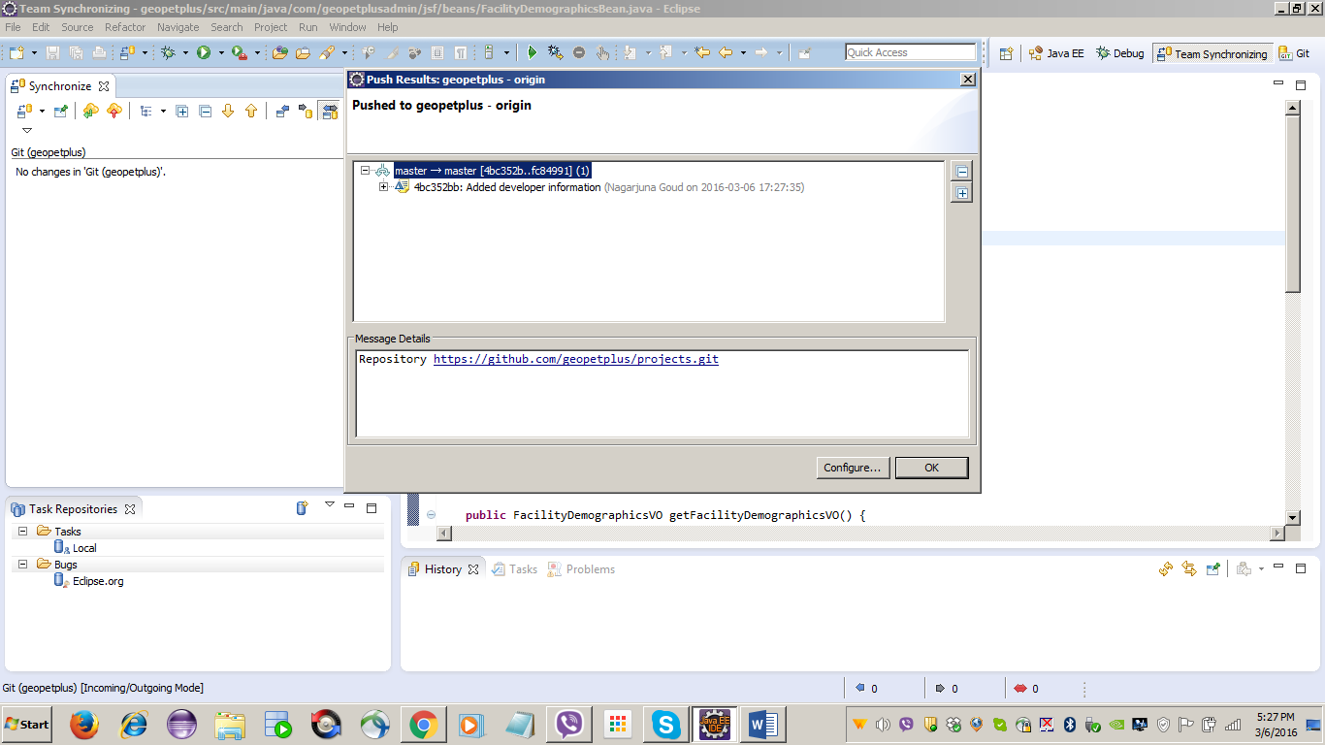

Happy Learning …!!

Thank You

